Crypto Market Data Scraper - Post Project Report
Automated Cryptocurrency Extraction and Analysis
Author: Artheesh E (Team 1)
Project Type: Individual Project

EXECUTIVE SUMMARY
The Crypto Market Data Scraper project demonstrates the implementation of an automated financial data extraction system using Python and Selenium. The solution addresses the volatility and rapid changes in the cryptocurrency market by providing a streamlined approach to collect, process, and export real-time market data from CoinMarketCap. The system targets the top 10 performing cryptocurrencies, delivering structured data in CSV format for immediate financial analysis.

PROJECT OVERVIEW
Objective
To develop an automated tool that extracts real-time cryptocurrency data (Coin Name, Price, Market Cap, 24h Volume), cleans the extracted strings, and exports the information into a structured CSV format for decision-making.
Scope
- Single-platform focus: CoinMarketCap.com
- Real-time extraction: Live market prices and volumes.
- Headless Browser Operation: Running scripts without a visible UI for efficiency.
- Data Export: Structured CSV generation via Pandas.
Key Features
- Automated Browser Control: Uses Selenium to navigate dynamic web content.
- Targeted Data Selection: Specifically extracts the top 10 market leaders.
- Robust Parsing: Identifies specific HTML tags (paragraphs, table cells, and spans) to isolate financial values.
- Headless Execution: Optimized for performance and server-side deployment.

TECHNICAL IMPLEMENTATION
Architecture
The system follows a linear processing pipeline:
- Driver Initialization: Configure Chrome options (headless mode, sandbox settings).
- Web Navigation: Accessing CoinMarketCap and waiting for DOM elements to load.
- Element Identification: Locating the main data table and row-specific cells.
- Data Extraction: Iterating through rows to pull Coin Name, Price, Market Cap, and 24h Volume.
- Data Structuring: Converting raw text into a list of Python dictionaries.
- Export Generation: Utilizing Pandas to create a clean CSV file.
Technology Stack
- Python 3.x: Core programming language.
- Selenium: Web automation and dynamic content scraping.
- WebDriver Manager: Automated management of binary drivers.
- Pandas: Data manipulation and CSV export.
- Chrome (Headless): The browser engine used for data retrieval.

PERFORMANCE METRICS
- Processing Capacity: Top 10 coins per execution (easily scalable).
- Execution Time: Approximately 10-15 seconds including driver overhead.
- Reliability: High success rate due to explicit WebDriverWait conditions.
- Output: Clean, comma-separated values compatible with Excel and BI tools.

SOURCE CODE IMPLEMENTATION (Screenshot):

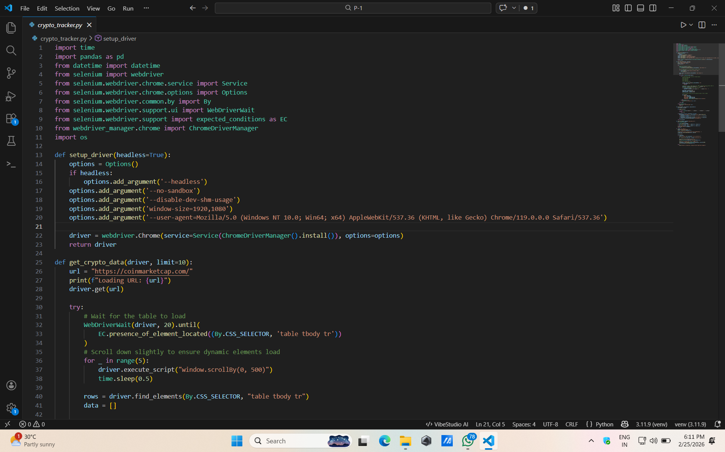
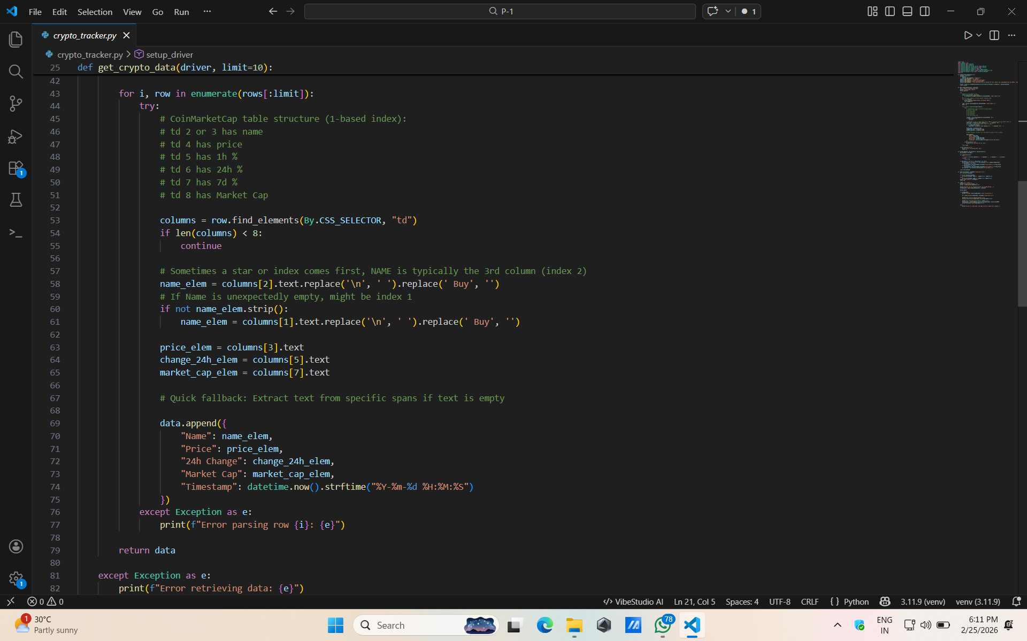

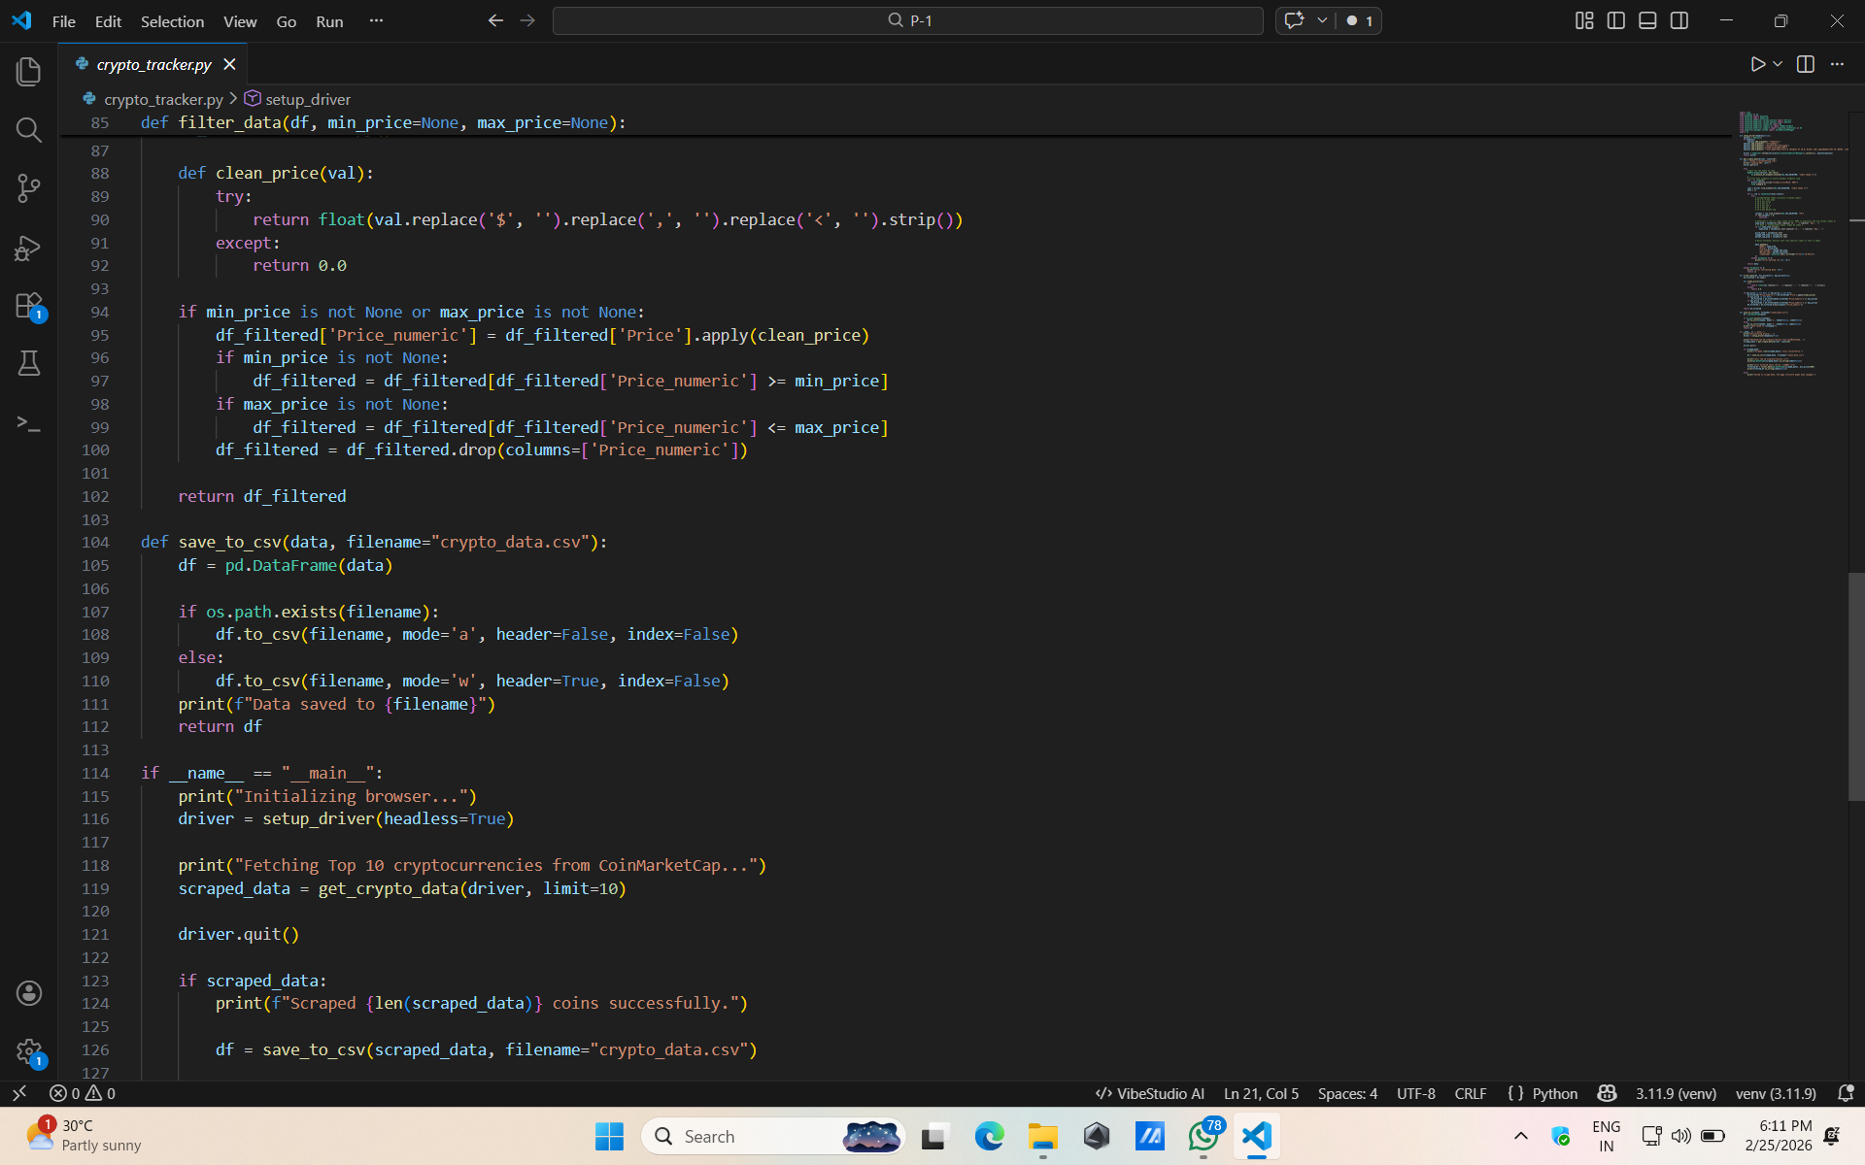
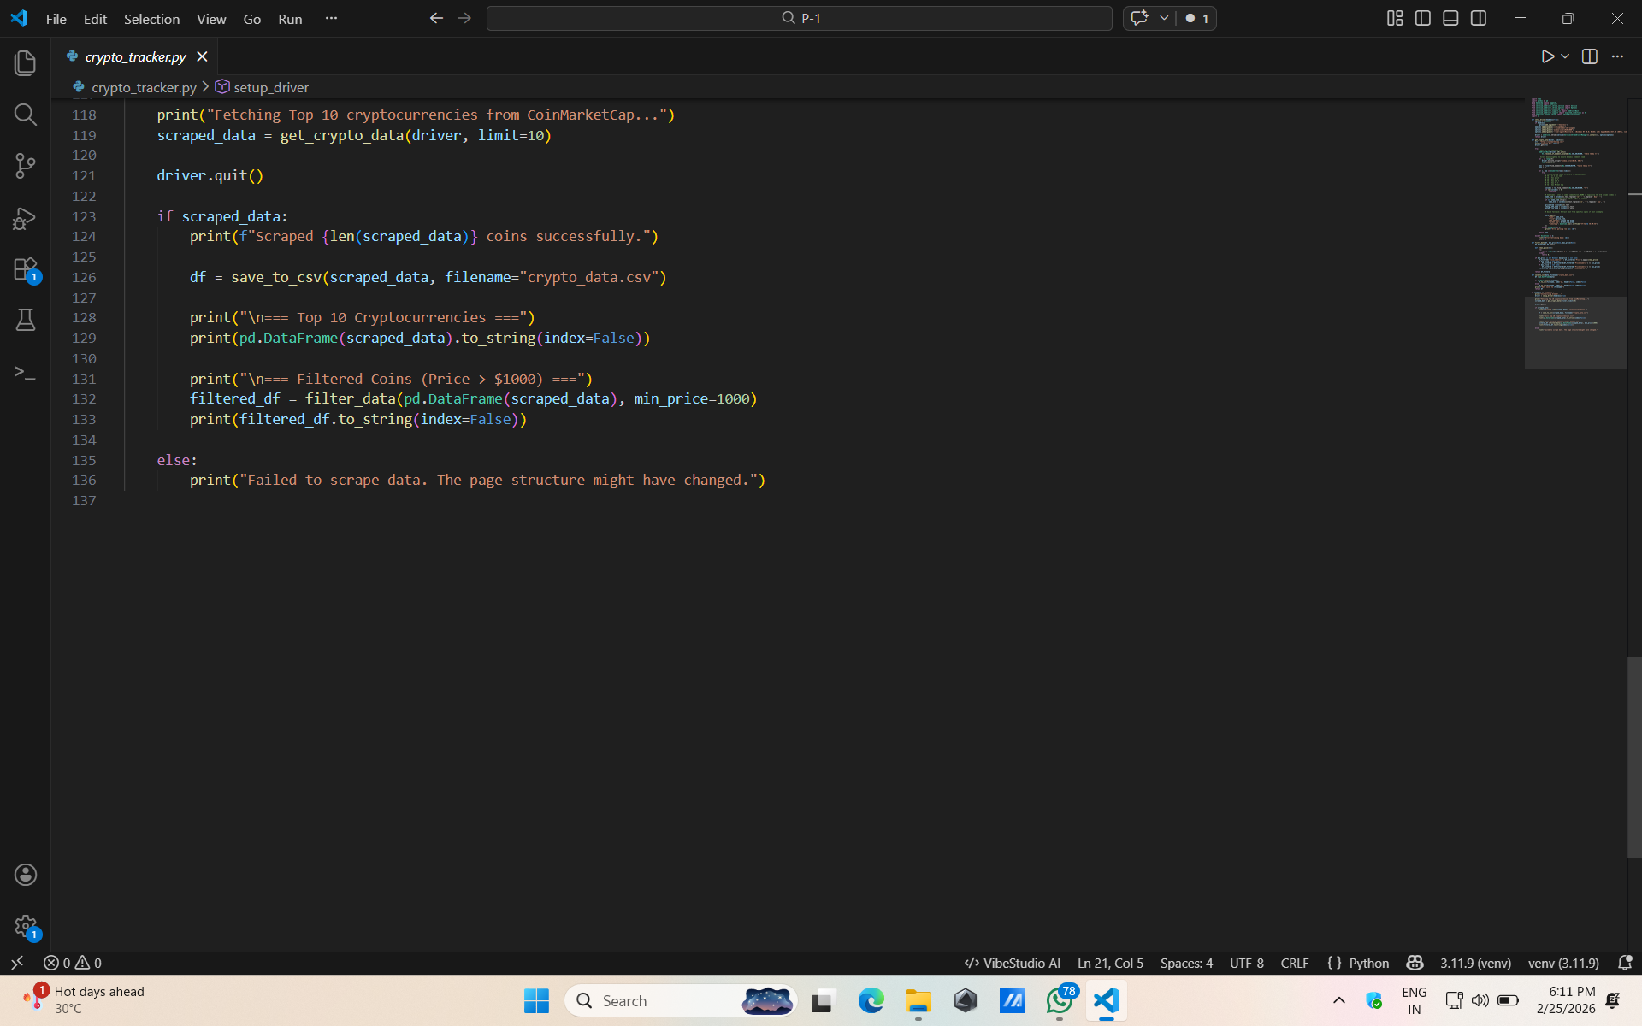

Result:
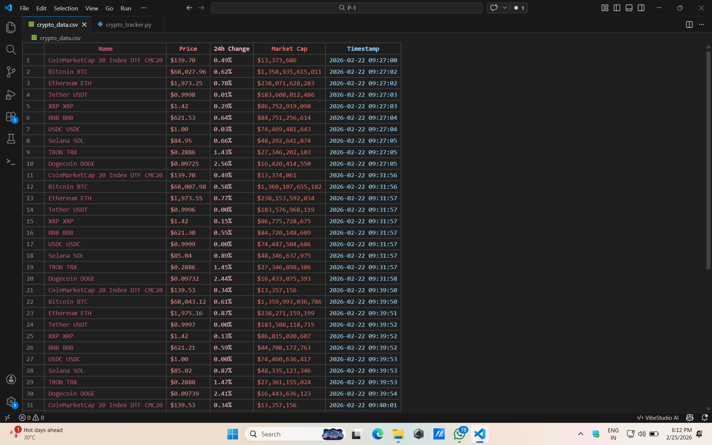

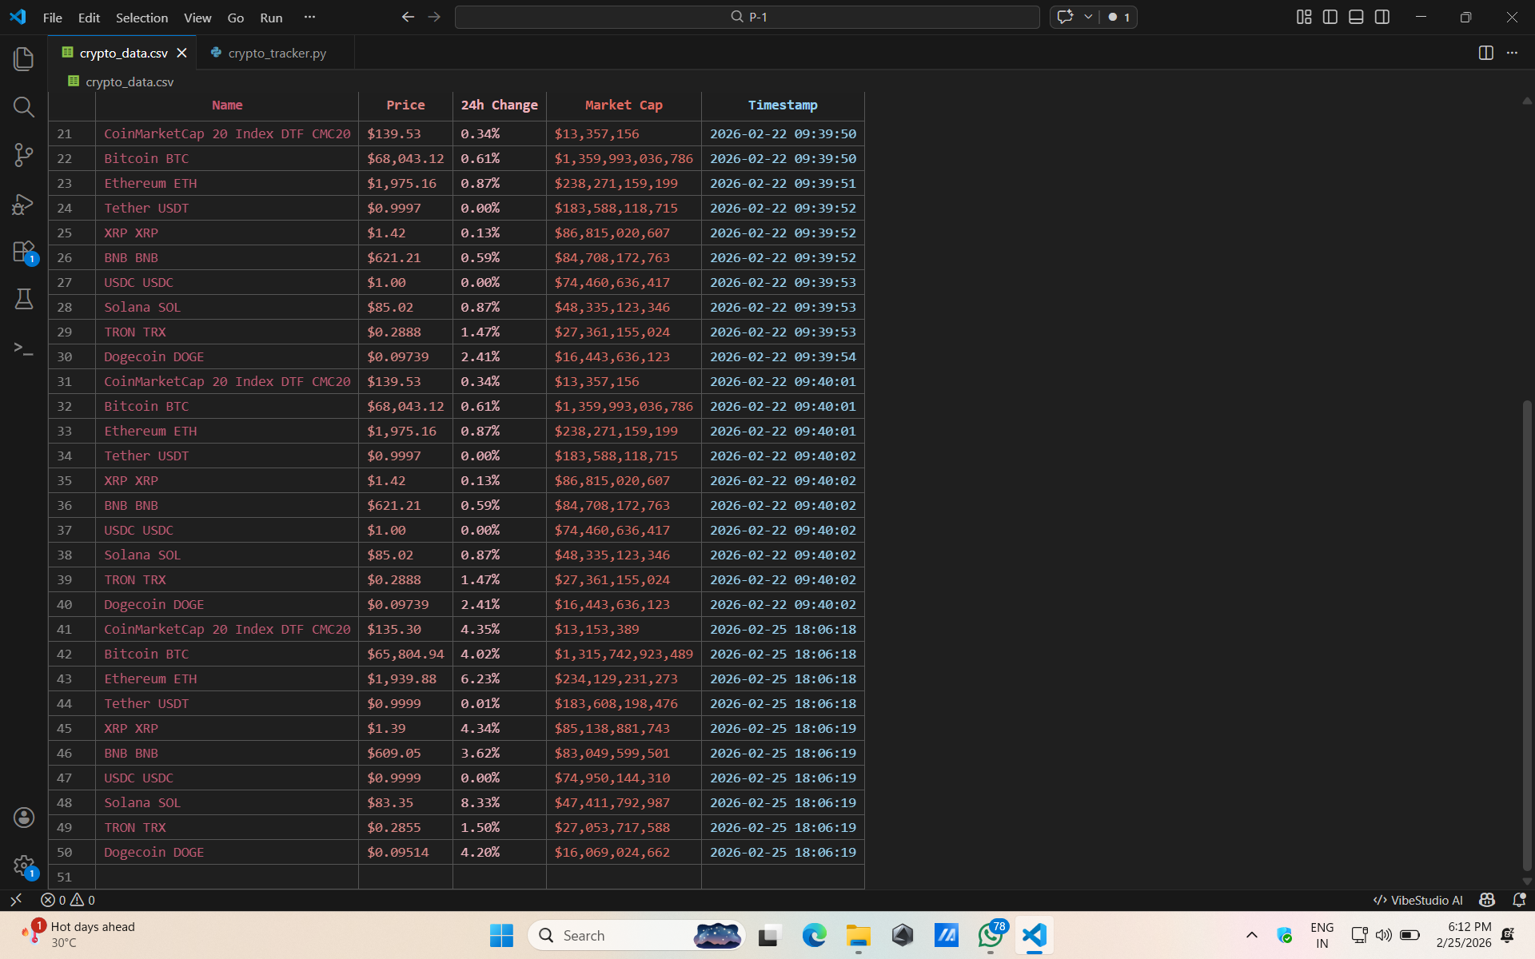
KEY ACHIEVEMENTS
Technical Accomplishments
- Dynamic Loading Handling: Successfully implemented WebDriverWait to handle asynchronous table loading.
- Clean Parsing: Navigated complex nested HTML structures (TD -> SPAN -> P) to find precise data points.
- Modular Design: Used Object-Oriented Programming (OOP) to separate driver logic from data processing.
Automation Benefits
- Consistency: Standardized data collection without human error.
- Efficiency: Replaces minutes of manual copying with seconds of automated execution.
- Ready-for-Analysis: Data is pre-formatted for mathematical modeling.

LIMITATIONS AND CONSTRAINTS
- Site Dependency: Changes in CoinMarketCap's HTML structure may require code updates.
- Rate Limiting: Aggressive scraping could lead to temporary IP blocking.
- Local Storage: Currently saves data to the local file system rather than a database.
- Platform Specific: Logic is tailored specifically for the CoinMarketCap layout.

CONCLUSION
The Crypto Market Data Scraper successfully demonstrates the practical application of web automation in the financial sector. By leveraging Selenium and Pandas, the project provides a foundation for more advanced market intelligence tools. Future enhancements will focus on multi-page scraping and real-time price alert integrations.

